開南大學交換學生定期報告書
2019年10月31日
姓名︰陳修壯 V大學部 □進修部 □碩士班 年級：4 學系：應用日語系
交換姐妹校︰ 岡山大學 開南導師︰劉懿禎
就學進度狀況︰
第一個月因為才剛開始適應在日本的生活所以有些稍為的緊張，但經過一個禮拜之後就有改善了。我在這的第一個學期所選的課有專門教外國人日文的課程，這個課程在開始選課前會舉辦一個分級考試，一共分七級。其他就可以選日本大學學部生的課，換句話說就是跟日本人一起上課。

交流活動狀況︰
我在開始上課之後就交到了蠻多朋友的，有美國人、土耳其人、中國人、德國人、法國人、印度人等等，是還沒有在這邊認識到日本人的朋友，但是因為我之前有參加應日系舉辦的一個活動，叫做"華英與研修團"，因為這個活動而讓我認識到來自日本各個大學的朋友，當然也包含現在我正留學的岡山大學的朋友，所以再來留學前我非常推薦各位可以去參加這個活動。這個活動的相關資訊可以在國際處諮詢。

生活狀況︰
一剛開始真的會有很多的問題，都要一一自己解決，比方說宿舍房間的一些設備有損壞阿、熱水器壞掉阿甚麼的，都要自己想辦法處理，盡快跟自己的指導教授聯絡阿，或是趕快跟宿舍管理員提出。畢竟岡山大學的留學生真的太多太多，老師們沒辦法各個都顧到，所以來留學的話盡快交一些朋友，會讓自己比較不那麼緊張。

其他：
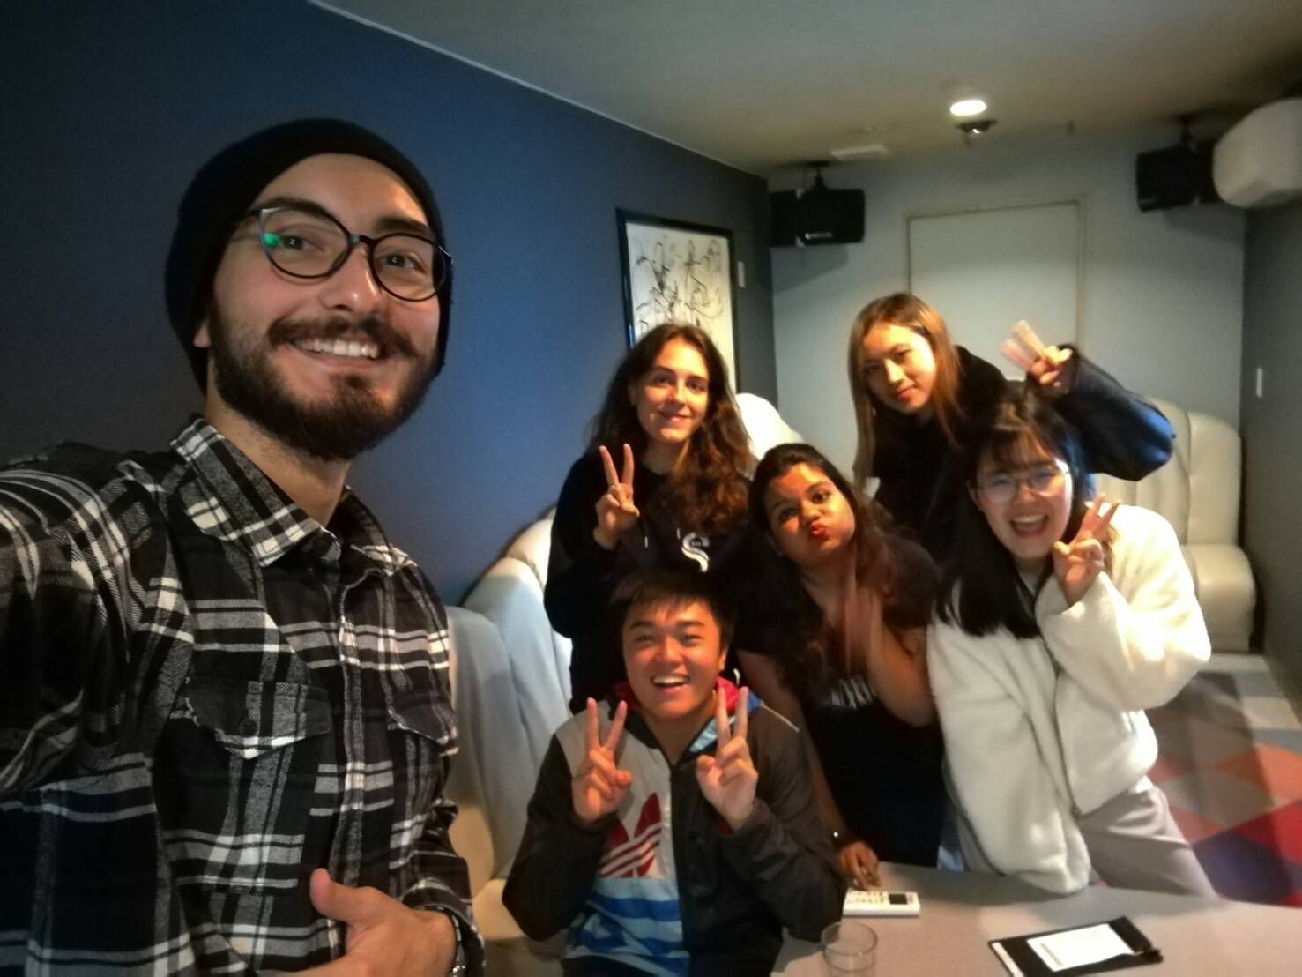

開南大學交換學生定期報告書
2019年9月30日
姓名︰陳修壯 V大學部 □進修部 □碩士班 年級：4 學系：應日系
交換姐妹校︰岡山大學 開南導師︰劉懿禎
就學進度狀況︰
尚未開學

交流活動狀況︰
因為才剛抵達日本，光是先處理自己的事情就來不及了，所以並沒有很多的交流，但是是有一些為留學生舉辦的說明會，這個一定要參加，這可以讓你迅速了解在日本生活要注意那些事情。

生活狀況︰
錢其身上現金一定要帶足，不然真的會很快就沒有錢了，我自己是帶了22萬現金，原本是要帶更多50萬，但是家人不同意帶那麼多現金在身上，說之後再用匯的，但是真的差一點用到沒錢，還好匯錢過來的天數沒有很長，不然真的會吃土。

其他：
有任何問題都可以請教我喔! 連絡我的時候請讓我知道你是開南大學的什麼系還有怎麼稱呼您喔!
我的Line ID:870325325
Email: s3camhh4thpss93300@gmail.com

